LAB # 05

Static Routes

**Objective:** To configure Static routes and changing its Administrative Distance

**Routing Protocols**

A routing protocol is a set of rules or standard that determines how routers on a network communicate and exchange information with each other, enabling them to select best routes to a remote network, each router has priority knowledge only of networks attached to it directly. Routers running routing protocol share this information first, among immediate neighbors, then throughout the entire network. This way, routers gain insight knowledge of the topology of the network.

Routing protocols perform several activities, including:

* Network discovery
* Updating and maintaining routing tables

The router which sits at the base of a network maintains a routing table, which is a list of networks and possible routes known by the router. The routing table includes network addresses for its own interfaces, which are the directly connected networks, as well as network addresses for remote networks. A remote network is a network that can only be reached by forwarding the packet to another router.

Remote networks are added to the routing table in two ways:

1. By the network administrator manually configuring **static** routes.
2. By implementing a **dynamic** routing protocol.

Dynamic Routing protocols are used by routers to share information about the reach ability and status of remote networks.

**Dynamic Routing Protocols**

There are several dynamic routing protocols for IP. Here are some of the more common dynamic routing protocols for routing IP packets:

* **RIP** (Routing Information Protocol)
* **IGRP** (Interior Gateway Routing Protocol)
* **EIGRP** (Enhanced Interior Gateway Routing Protocol)
* **OSPF** (Open Shortest Path First)
* **IS-IS** (Intermediate System-to-Intermediate System)
* **BGP** (Border Gateway Protocol

**Advantages of dynamic routing protocols**

1. Dynamic routing protocols update and maintain the networks in their routing tables.
2. Dynamic routing protocols not only make a best path determination to various networks, they will also determine a new best path if the initial path becomes unusable or there is a change in the topology.
3. Routers that use dynamic routing protocols automatically share routing information with other routers and compensate for any topology changes without involving the network administrator.

**Classification of Dynamic Routing Protocols**

Dynamic routing protocols can be classified in several different ways. I will discuss two classifications: exterior protocols versus interior protocols, and distance-vector versus link-state protocols. The first classification is based on where a protocol is intended to be used: between your network and another's network, or within your network. The second classification has to do with the kind of information the protocol carries and the way each router makes its decision about how to fill in its routing table.

**Exterior vs. Interior Protocols**

An exterior protocol carries routing information between two independent administrative entities, such as two corporations or two universities. Each of these entities maintains an independent network infrastructure and uses an EGP (Exterior Gateway Protocol) to communicate routing information to the other. Today, the most common exterior protocol is the *Border Gateway Protocol (BGP)*. It is the primary exterior protocol used between networks connected to the Internet, and was designed specifically for such purposes.

In contrast, an interior protocol is used within a single administrative domain, or among closely cooperating groups. In contrast to the exterior protocols, IGPs tend to be simpler and to require less overhead in a router. Their primary drawback is that they can't scale to extremely large networks. The most common interior protocols in IP networks are the *Routing Information Protocol (RIP), Open Shortest Path First (OSPF),* and the *Enhanced Interior Gateway Routing Protocol (EIGRP)*.

**Distance-Vector vs. Link-State Protocols**

Another way to classify dynamic routing protocols is by what the routers tell each other, and how they use the information to form their routing tables. Most protocols fit into one of two categories.

**Distance-vector Routing Protocol**

In a ***distance-vector*** protocol, a router periodically sends all of its neighbors two pieces of information about the destinations it knows how to reach. First, the router tells its neighbors how far away it thinks the destination is; second, it tells its neighbors what direction (or vector) to use to get to the destination. This direction indicates the next hop that a listener should use to reach the destination,

The other part of the protocol, the distance, is where distance-vector protocols differ. In each case, the protocol uses some ***metric*** to tell the receiving routers how far away the destination is. This metric may be a true attempt at measuring distance (perhaps using a periodic measure of the round trip time to the destination), something that approximates distance (such as hop count), or it may not measure distance at all. Instead, it may attempt to measure the cost of the path to the destination. It may even involve a complex computation that takes into account factors like network load, link bandwidth, link delay, or any other measure of the desirability of a route. Finally, it may include an administrative weight that is set by a network administrator to try to cause one path to be preferred over another.

**Link-state Routing Protocol**

In a ***link-state protocol***, a router doesn't provide information about destinations it knows how to reach. Instead, it provides information about the topology of the network in its immediate vicinity. This information consists of a list of the network segments, or *links*, to which it is attached, and the *state* of those links (functioning or not functioning). This information is then *flooded* throughout the network. By flooding the information throughout the network, every router can build its own picture of the current state of all of the links in the network. Because every router sees the same information, all of these pictures should be the same. From this picture, each router computes its best path to all destinations, and populates its routing table with this information.

|  |
| --- |
| Distance-vector and link-state protocols have their own strengths and weaknesses. In a properly functioning and configured network, either type yields a correct determination of the best path between any two points. However, this is not to say that there are not tradeoffs involved in selecting one type of protocol over another. |

**Static routing**

Static routing occurs when you manually add routes in each router's routing table. There are advantages and disadvantages to static routing, but that's true for all routing processes.

***Static routing has the following advantages:***

* There is no overhead on the router CPU. The routing protocols can be disabled on the router.
* There is no bandwidth usage between routers.
* It adds security because the administrator can choose to allow routing access to certain networks only.

***Static routing has the following disadvantages:***

* The administrator must really understand the internetwork and how each router is connected in order to configure routes correctly.
* If a network is added to the internetwork, the administrator has to add a route to it on all routers—manually.
* It's not possible in large networks because maintaining it would be a full-time job in itself.

**Administrative Distance (AD)**

Administrative Distance or AD is an integer from 0 to 255 that rates the trustworthiness of routing information received on a router from a neighboring router. The AD is used as the tie-breaker when a router has multiple paths from different routing protocols to the same destination. The lower the path’s AD, the more likely it is to be used

Below is the Administrative Distance of different Routing Protocols

***Routing Information Source Administrative Distance***

|  |  |
| --- | --- |
| **Directly Connected Interface** | 0 |
| **Static Route** | 1 |
| **EIGRP** | 90 |
| **IGRP** | 100 |
| **OSPF** | 110 |
| **RIP** | 120 |
| **External EIGRP** | 170 |
| **Unknown** | 255 |

**Topology Diagram :**

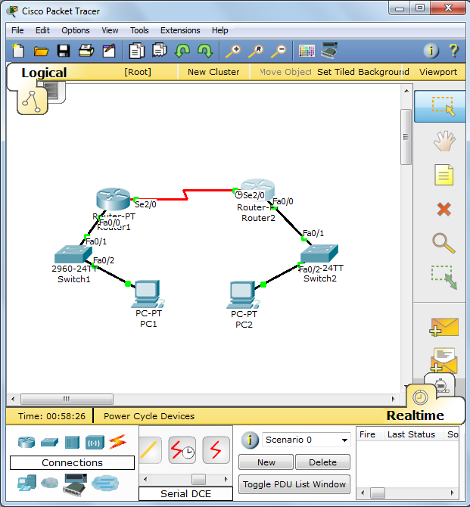

* **Router1 CONFIGURATION**

Router1(config)#**interface serial 2/0**

Router1(config-if)#**no shutdown**

Router1(config-if)#**ip address 10.0.0.1 255.0.0.0**

Router1(config)#**interface fastEthernet 0/0**

Router1(config-if)#**ip address 11.0.0.1 255.0.0.0**

Router1(config-if)#**no shutdown**

* **Configuring Static Route and changing its Administrative Distance to 150**

Router1(config)#**ip route 12.0.0.0 255.0.0.0 10.0.0.2 150**

* **Router2 CONFIGURATION**

Router2(config)#**interface serial 2/0**

Router2(config-if)#**no shutdown**

Router2(config-if)#**ip address 10.0.0.2 255.0.0.0**

* **Assign Clock rate on only DCE end**

Router2(config-if)#**clock rate 64000**

Router2(config-if)#**exit**

Router2(config)#**interface fastEthernet 0/0**

Router2(config-if)#**ip address 12.0.0.1 255.0.0.0**

Router2(config-if)#**no shutdown**

* **Configuring Static Route and changing its Administrative Distance to 150**

Router2(config)# **ip route 11.0.0.0 255.0.0.0 10.0.0.1 150**

**Verifying Static Routes**

* **Only listing configured Static Routes, note that 150 in brackets is the manual AD of static routes (Default = 1), and the ‘0’ is its cost**

Router1# **show ip route static**

S 12.0.0.0/8 [150/0] via 10.0.0.2

* **Checking Routing Table**

Router1# **show ip route**

Codes: C - connected, S - static, I - IGRP, R - RIP, M - mobile, B - BGP

D - EIGRP, EX - EIGRP external, O - OSPF, IA - OSPF inter area

N1 - OSPF NSSA external type 1, N2 - OSPF NSSA external type 2

E1 - OSPF external type 1, E2 - OSPF external type 2, E - EGP

i - IS-IS, L1 - IS-IS level-1, L2 - IS-IS level-2, ia - IS-IS inter area

* - candidate default, U - per-user static route, o - ODR

P - periodic downloaded static route

Gateway of last resort is not set

C 10.0.0.0/8 is directly connected, Serial2/0

C 11.0.0.0/8 is directly connected, FastEthernet0/0

S 12.0.0.0/8 [150/0] via 10.0.0.2

**Default routes Configuration**

Default routes are static routes that you define for packets bound to a destination network that is not found in any of the routing tables on the router. Whenever the router receives packets bound to a network the router doesn’t know, it sends the packet out on the default route.

Default routes are related to default gateways. A default route is a data transmission path to the default outbound gateway in a network.

* **Define a default route on Router to bound serial interface 0/0**

Router(config)#**ip route 10.0.0.1 255.0.0.0 serial 0/0**

Router(config)#**exit**

Now router sends data packet bound for unknown networks out on serial 0/0

* **You can also use the IP address of the default gateway to configure a default route**

Router(config)#**ip route 0.0.0.0 0.0.0.0 192.168.67.1**

Router(config)#**exit**

**Assignment :**

1. Write difference between Routing and Routed protocols
2. Describe a network route
3. Difference between static and default routes